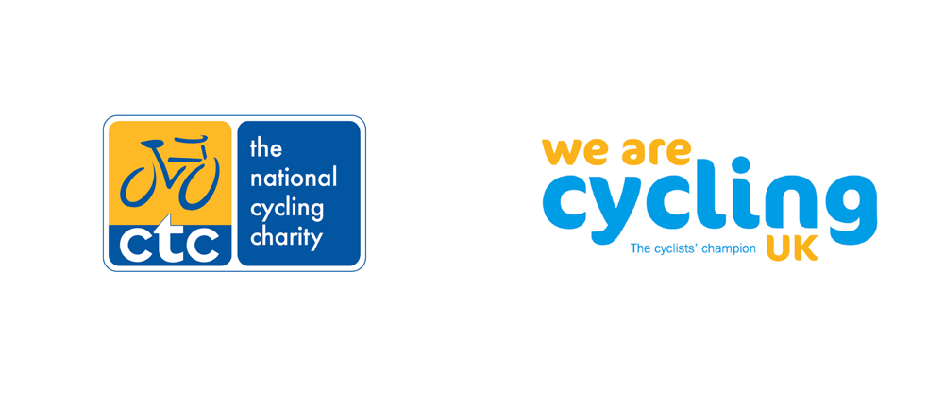
Chairman’s report 2018
It has been quite a good year for Huddersfield CTC (now part of Cycling UK) the new club kit has been a great success and it is good to see a lot of riders out sporting the kit. It looks great and also is good advertising for the club.
There have been some good cycle tours throughout the year. Kettlewell 2 day tour of the Yorkshire Dales was a success going through some stunning scenery and doing some classic climbs although the number attending were down on last year. Some members embarked on a 7 day tour of the Czech Republic which was something new. One member once again completed the Samaine Federal in France and 7 members completed the UK Coast to Coast ride which was a great achievement as some of our younger members were 12, 14 and 16 years old.
The club finances are in good order despite spending a large amount subsidising club kit. And a special thank you to Ian Buday for keeping our accounts in order and website up to date
The Tuesday evening rides were once again well supported and a big thanks to Alan Priim for organising these, I hope he does the same next year. Wednesday rides have also been well attended and we have had some good Sunday rides but attendances have been down in recent months on the Sunday rides and I would like some input from members how we can address this and what type of rides members want and what rides will encourage new members to join us.
Finally I would like to thank all committee members for their work during the past year and I hope you can do the same in the coming year.

Steve Randerson
Chairman

